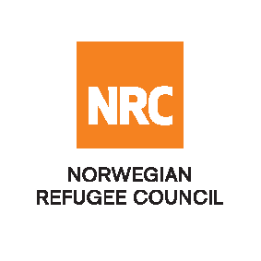

INVITATION TO TENDER

The Norwegian Refugee Council (NRC) is a non-governmental, humanitarian organization with 76 years of experience in helping to create a safer and more dignified life for refugees and internally displaced people. NRC advocates for rights and aids, protection and durable solutions to refugees and internally displaced persons worldwide.

NRC has been operating in Nigeria since late 2015 aiding with Emergency shelter, Livelihoods and Food Security, Water, Sanitation and Hygiene sectors, Information Counseling and Legal Assistance, Camp Management, and Education.

Norwegian Refugee Council (NRC) invites bids from competent service providers in Nigeria for the following category of service:

No | Tender Reference Number | Category of Service | Closing date
1 | 23/NRC-NAT/NG/2026 | PROVISION OF HOTEL ACCOMMODATION AND CONFERENCE FACILITIES/REFRESHMENTS IN ZAMFARA | 20th July 2026

All applications/proposals must duly complete and submitted through e-mail address: ng.tenders2@nrc.no

Late bids shall be rejected, and no liability will be accepted for loss, late delivery or non-delivery, whatsoever.

NRC reserves the right to select/reject any bids, in part or full, as it may deem necessary. No liability or claim in that respect would be admissible or entertained whatsoever.

